**Please change the validation message of all field like:-**

1. **If it is a name text field :-** First / Last name field is required.
2. **If it is DOB / DOJ :-** Please select the Date of Birth / Joining.
3. **If it is a drop down :-** Please select the “ field name.”
4. **If a user enters the invalid email address / Mobile format :-** Please enter a valid email address / mobile number.
5. Click on Save when all text fields are blank.

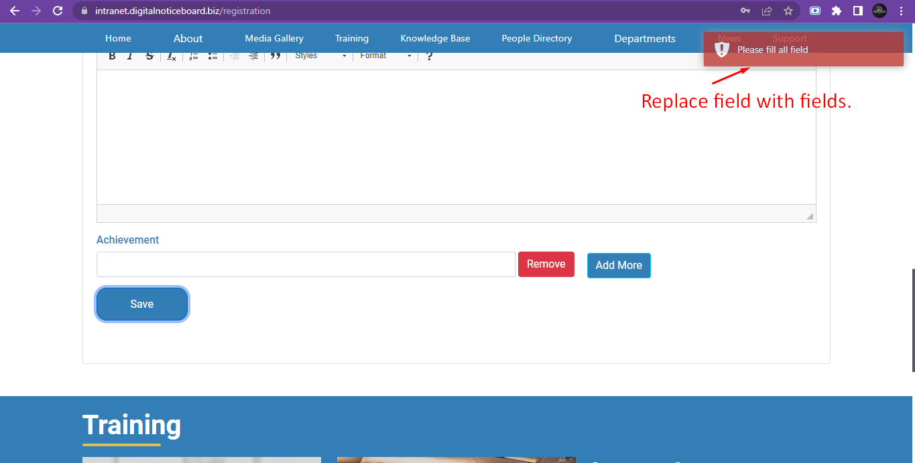



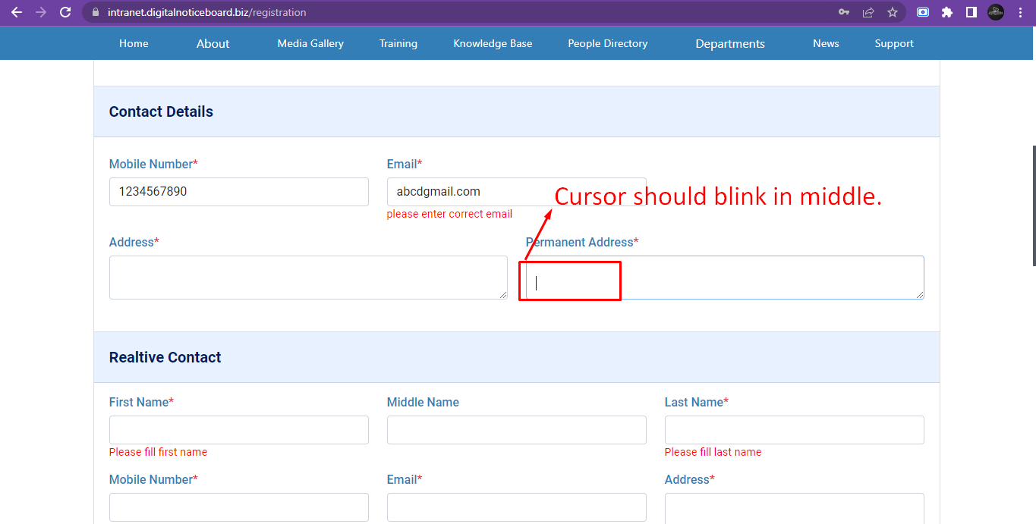

1. Should not take Date of birth and Date of joining in future dates.
2. Keep About text field blank and click on save > website gets crashed. Plewe

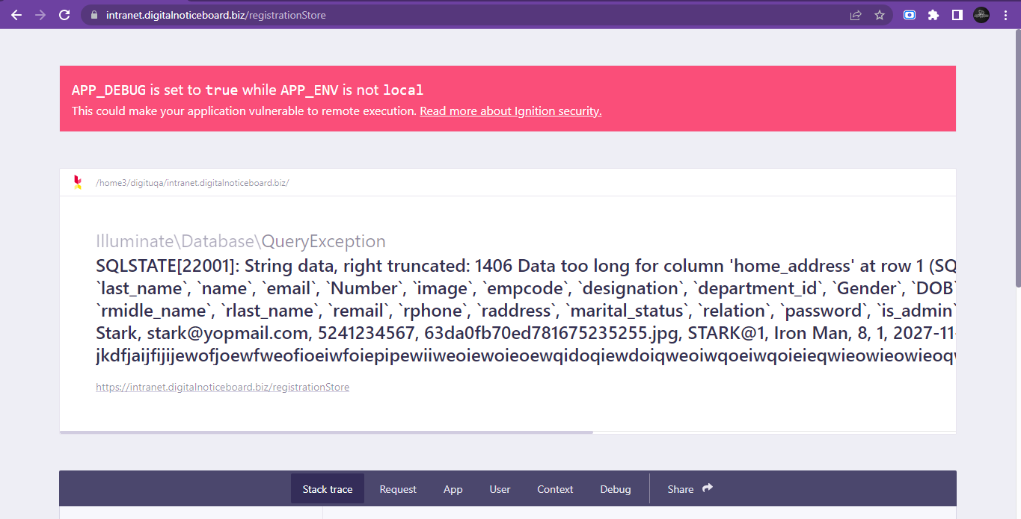

1. Spelling error of relative.

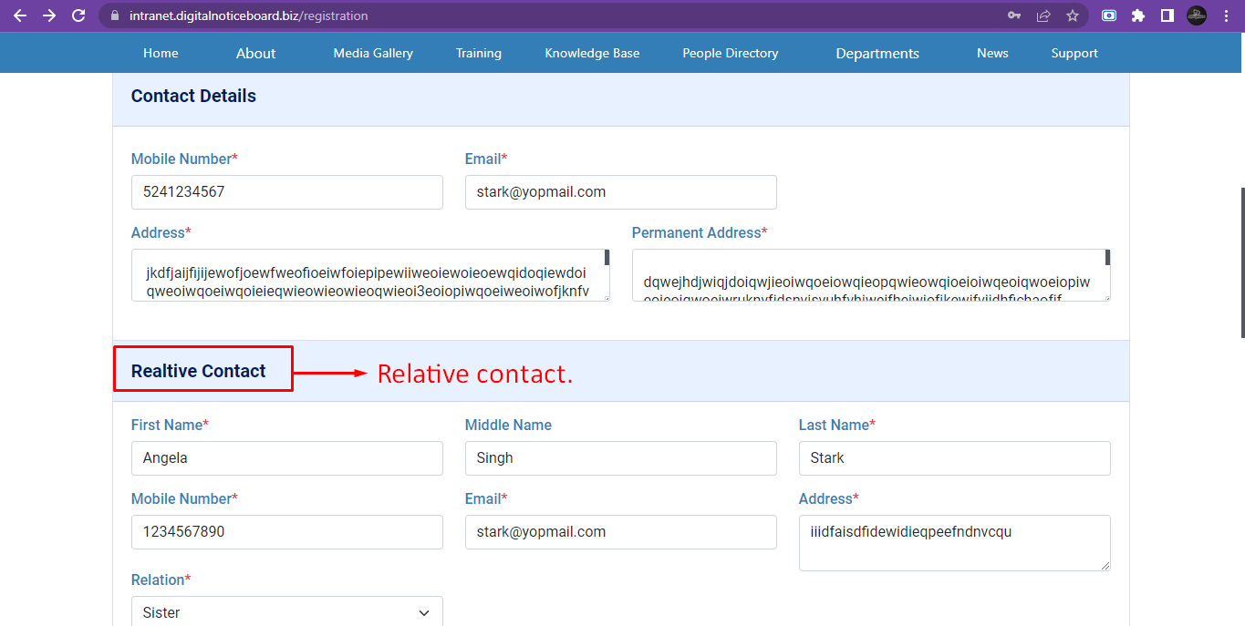

1. Only .jpg, .png, .jpeg should be allowed in profile picture upload. Should not able to upload .doc , .pdf like file types .

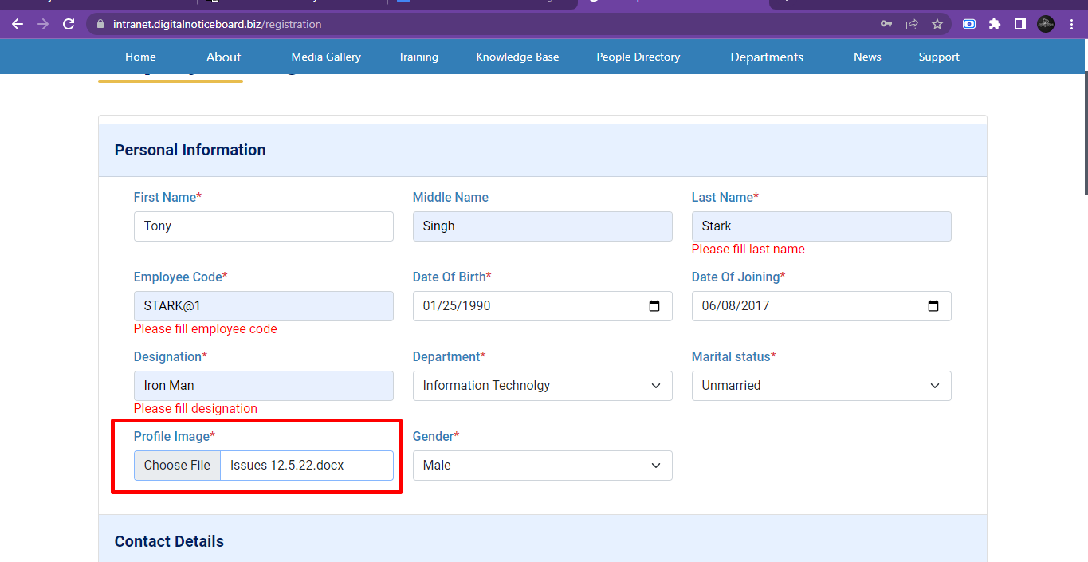

1. Change the validation message to “ Please select the date of joining. “

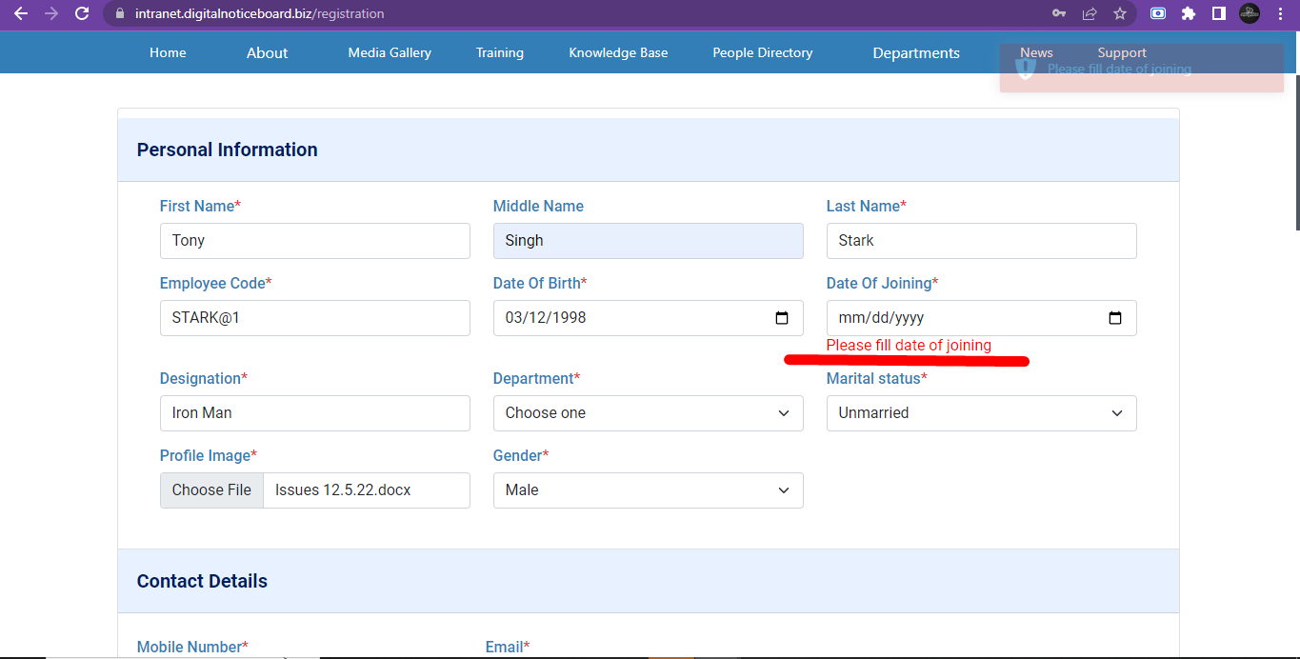

1. No validation message in Gender. Add validation message “ Please select Gender ”

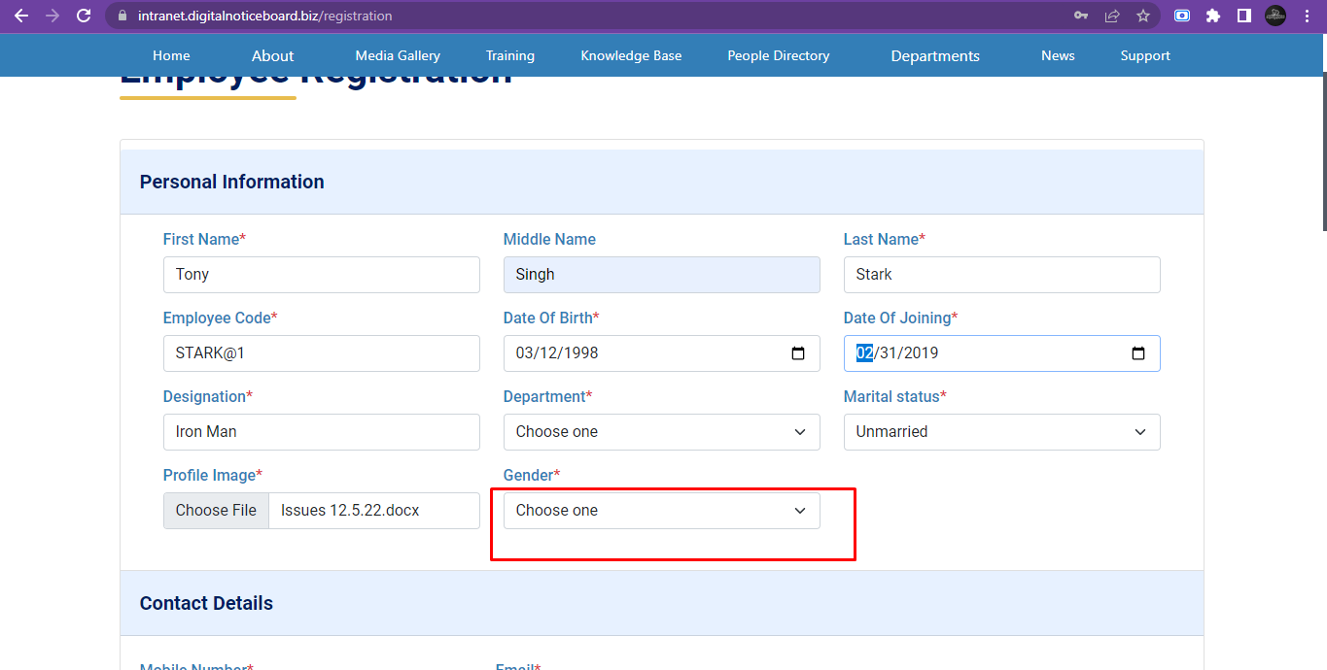

1. No validation message in mobile number. Add validation message “ Please enter mobile number.”
2. Date of birth & joining field - the whole field should be clickable. Currently shows calendar on click of icon
3. Choose one text - keep the o in capital like “Choose One”
4. Marital status - S should be capital like “Marital Status”
5. Success message should be “Successfully registered” instead of Successfully stored
6. App got crash if i enter existing email address : -

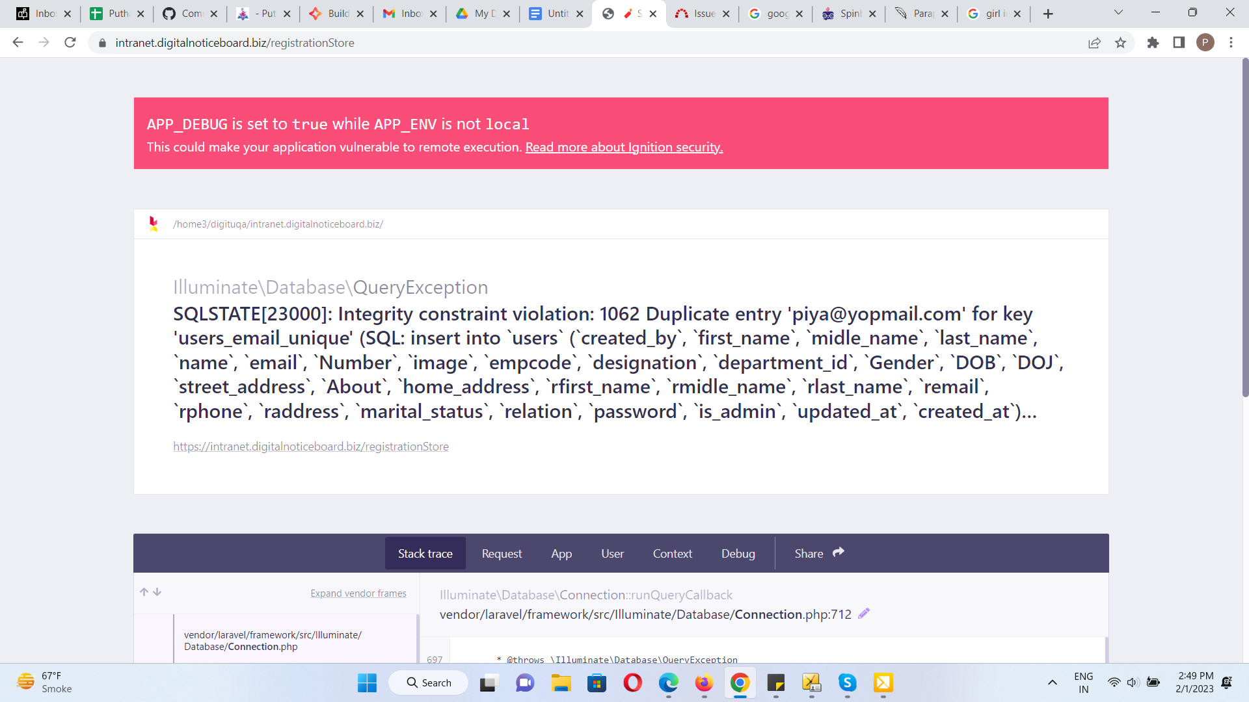

1. Achievement > click on add more and the click remove > displaying blank space.

Video link :- [**https://www.screencast.com/t/MN3BxFzwH9**](https://www.screencast.com/t/MN3BxFzwH9)

1. Anniversary field should gets opened when user select Married in Marital Status.

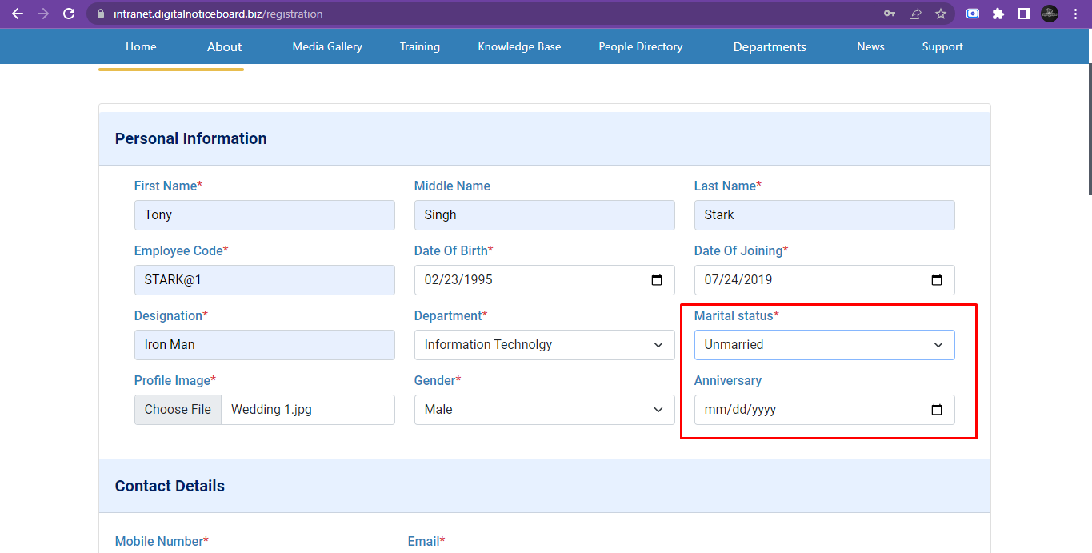

1. Contact Details > Change address to Current Address.

