**Credit Union**

The instructions for completing the form looks like they are a part of the form and should be differentiated.

**APPLICATION DETAILS**

1. The application form begins with question 2.
2. “Date of Application” should be placed above the date entered.



1. The line which allows for the uploading of documents should go next to the yes/no option as oppose to under.



1. Name of Co-operative society is redundant.

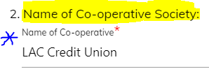

1. This question should not have a yes or no option. This information should always be provided.

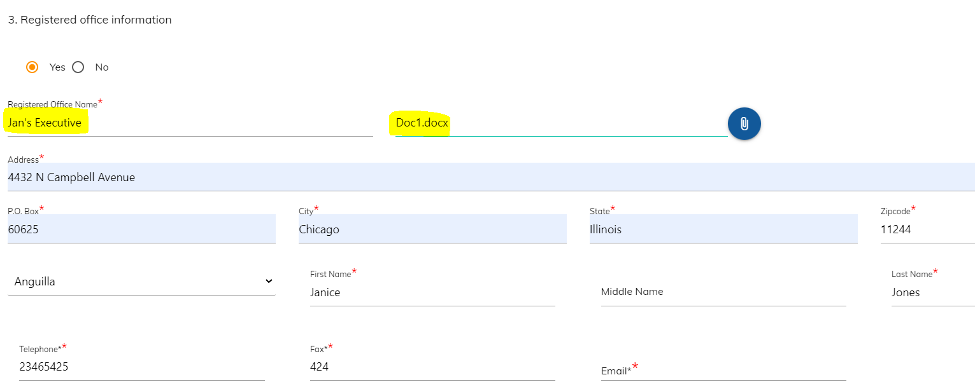

1. The highlighted section should be taken to the next line and clearly labelled as “Principal representative of the registered agent”.

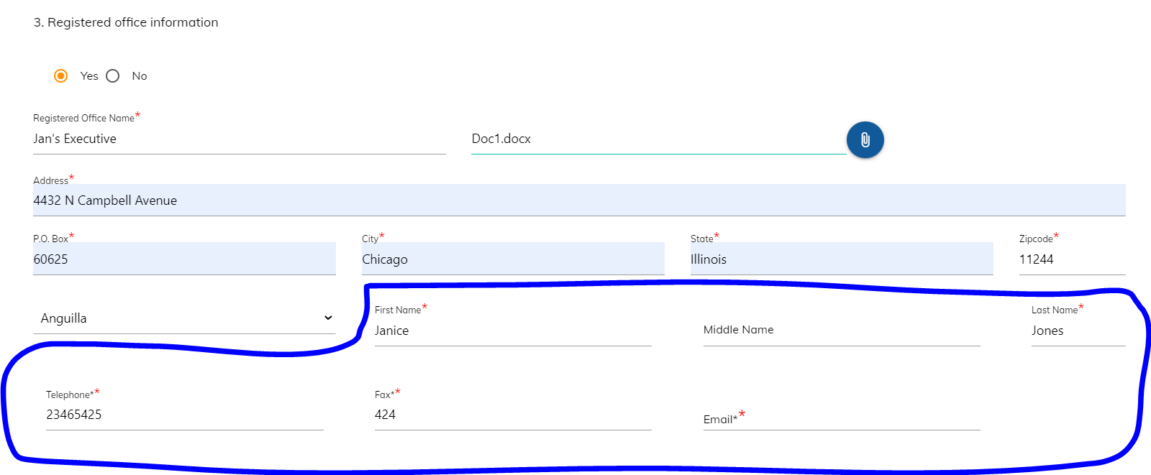

1. This should be a yes or no function and the upload option should be visible irrespective of what answer is given, whether yes or no. Please add upload option.



1. *“No. of Shares*” redundant.

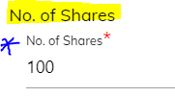

1. Items to be aligned.

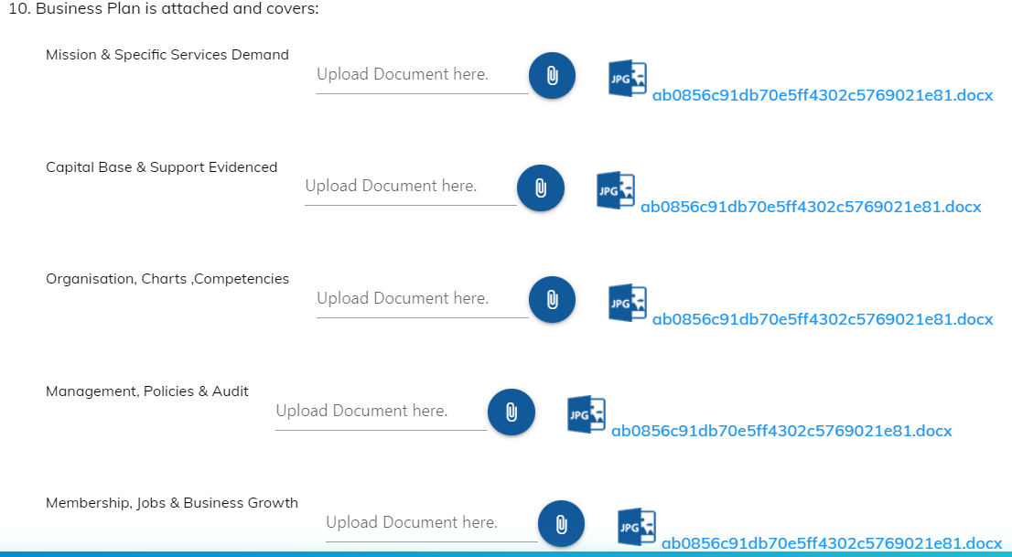

1. *“Date the society was established”* redundant.



1. *“Number of members signed on to date”* should be above the line.



**Members of Applicant**

1. Information displayed below should be visible to the user at all times. Kindly format the table to allow for this.

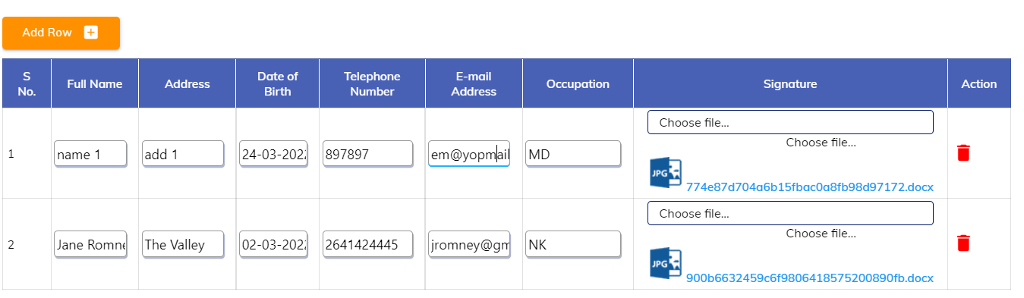

**PROVISIONAL DIRECTORS**

1. Please remove the check box

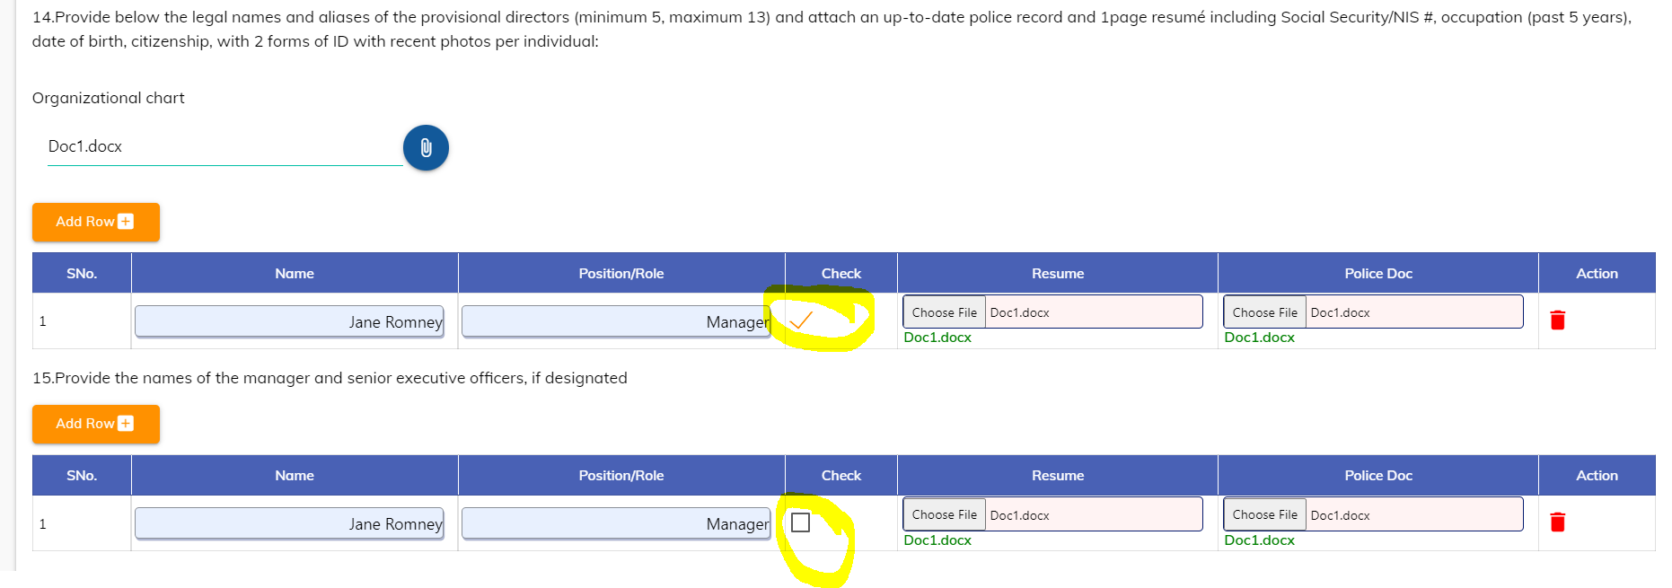

**DOCUMENTATION**

1. This form has the option to select a checkbox for attached items, however, there is no upload option available.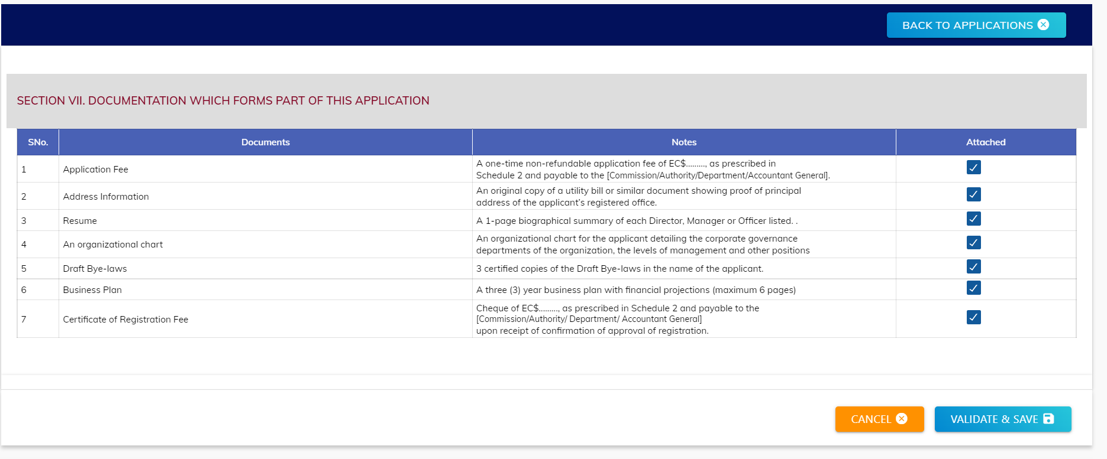

**DECLARATION PARTICULARS**

1. The “reason” should only appear if “Yes” is selected. Please remove *“(Give reason for the change)”*



1. The question number (26) has not been assigned to “Place of Change”.

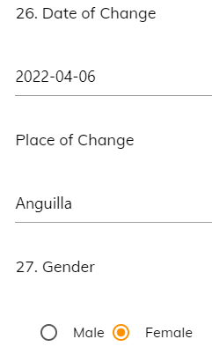

1. In the screenshot below, the option is not available for the user to enter NIS# and National ID# if applicable nor is there an upload option for the user to attach the passport page.

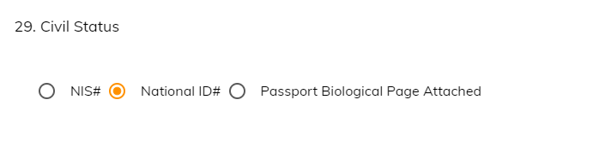

**Documentation Checklist**

1. The checklist should allow the user to select which CDD items have been “attached”. However, an upload option is not available.

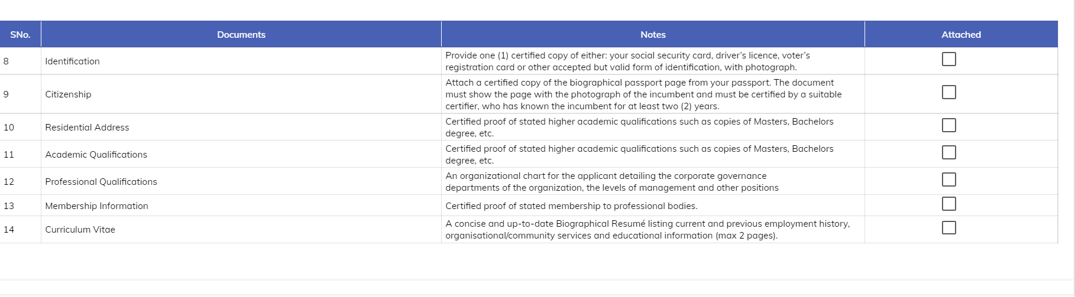

**General Comment**

1. All sections should be clearly labelled at the top as seen in screenshot below.

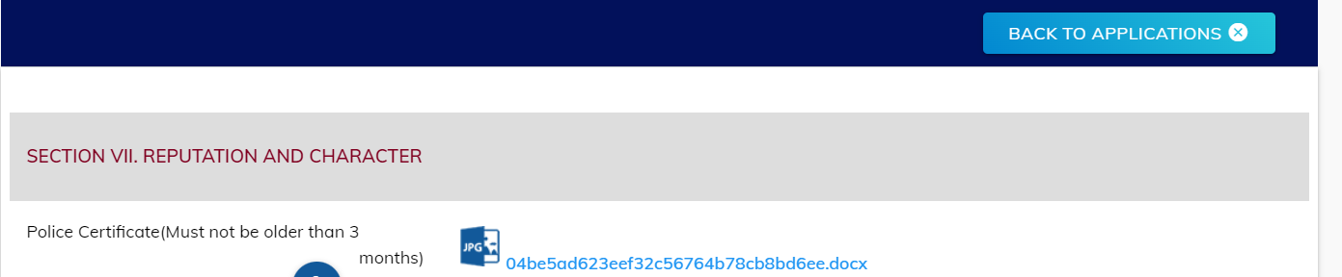

**MLRO/MLCO/CO**

1. Highlighted text should read “Name of Spouse”

