**Cu Client feedback point Query**

**Updated sheet after call: June 8, 2022**

**Updated By: Arti Saraswat**

**URL --** <https://demo.lfsc.digitalnoticeboard.biz/Licensee_new/edit_formDetails/TlRBeVh6UTJYekkwT1RRPQ>==

Login id -- [cu_irfan@yopmail.com](mailto:cu_irfan@yopmail.com)

Pass – 123456

**DOCUMENTATION**

1. This form has the option to select a checkbox for attached items, however, there is no upload option available.1 (This comment in feedbacksheet from client end)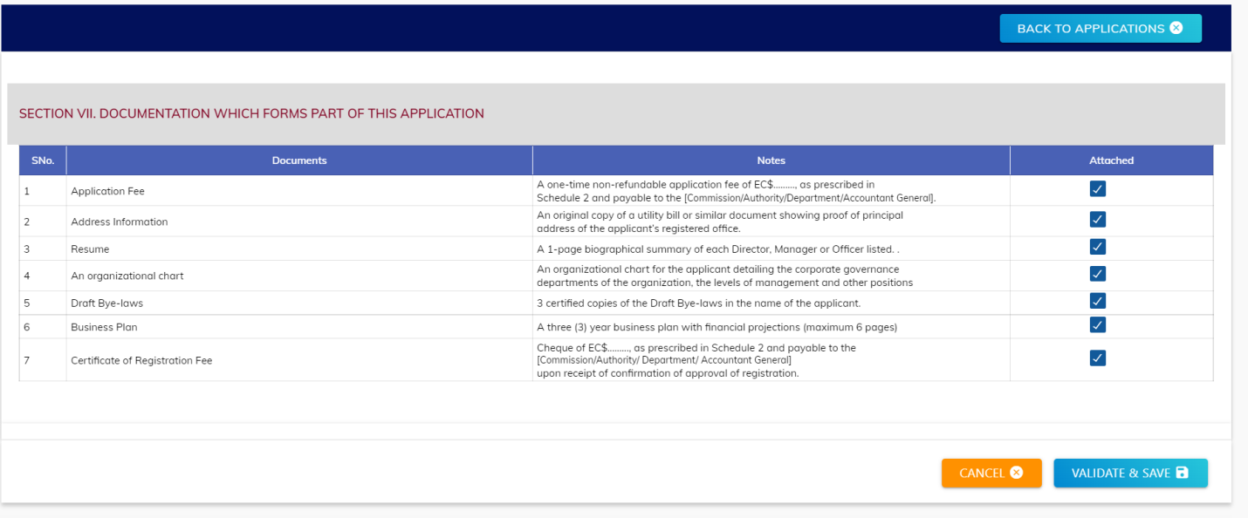

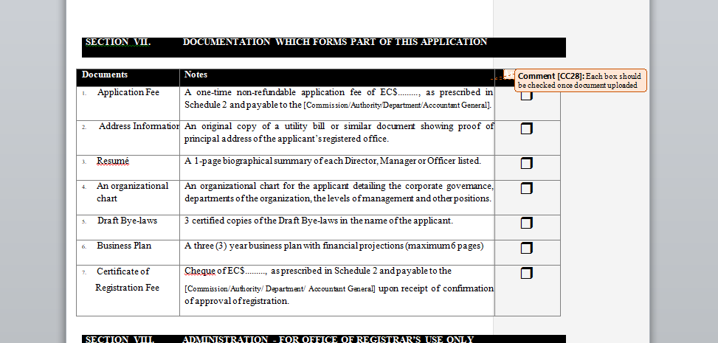

**Client comment Feb 12, 2022**

**The information requested in 11 to 14 below should have been uploaded in response to a questions higher up in the form. So instead of an upload function these should be check boxes.**

**MIPL Query:** Do we need to add upload option for every question?

**Client comment over call (June 8, 2022):**

1. Need to merge “**DOCUMENTATION”** and **“Documentation Checklist”** form into single form and all points will be only checklist.
2. Need to rename the form “ Documentation Application”

URL -- <https://demo.lfsc.digitalnoticeboard.biz/Licensee_new/edit_formDetails/TlRBeVh6UTRYekkwT1RZPQ>==

Login id -- [cu_irfan@yopmail.com](mailto:cu_irfan@yopmail.com)

Pass – 123456

**Form name: DECLARATION PARTICULARS**

1. The question number (26) has not been assigned to “Place of Change”.

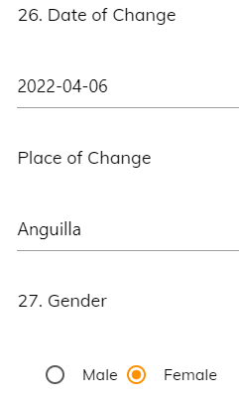

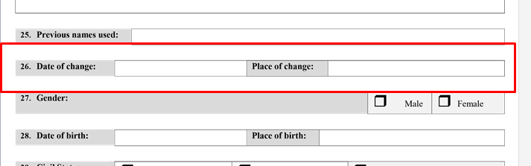

**MIPL Comment:** Are these two input field (Date of change & Place of change) to be assigned in the same line?

**Client comment over call (June 8, 2022):**

**No need to change anything in this**

1. In the screenshot below, the option is not available for the user to enter NIS# and National ID# if applicable nor is there an upload option for the user to attach the passport page.

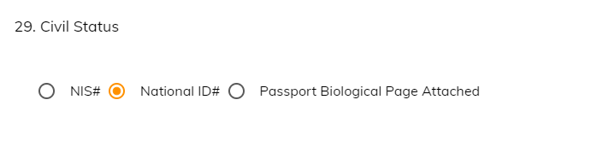

**MIPL QUERY:** Need more clarification over this point.

**Client comment over call (June 8, 2022):**

Need to add upload option option for every radio button.

URL-- <https://demo.lfsc.digitalnoticeboard.biz/Licensee_new/edit_formDetails/TlRBeVh6VTBYekkxTURJPQ>==

Login id -- [cu_irfan@yopmail.com](mailto:cu_irfan@yopmail.com)

Pass – 123456

**Documentation Checklist**

1. The checklist should allow the user to select which CDD items have been “attached”. However, an upload option is not available.

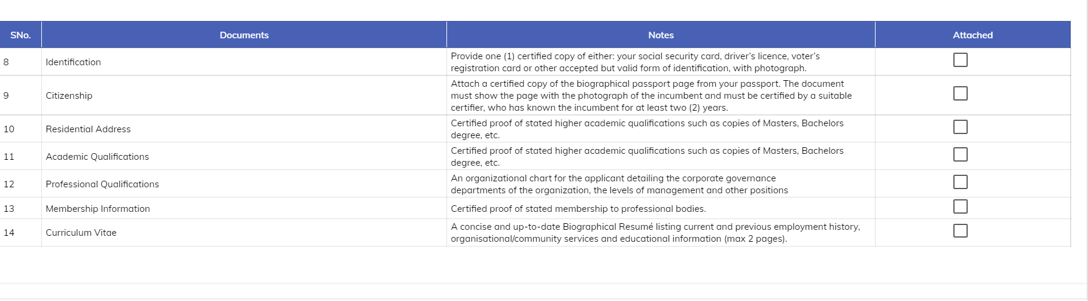

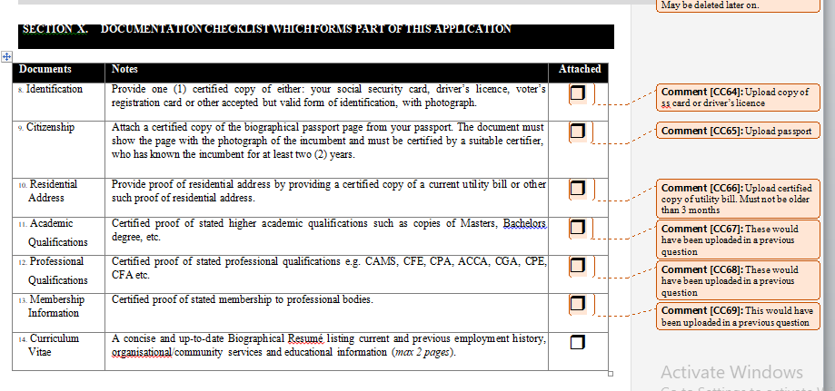

**MIPL Query:** Do we add the upload option for this question?

Need clarification over this statement : ***“The checklist should allow the user to select which CDD items have been “attached”.***

**Client comment over call (June 8, 2022):**

***Added comment in query 1***

**Sector insurance**

**Schedule 2**

**url -->** <https://demo.lfsc.digitalnoticeboard.biz/Licensee_new/edit_formDetails/TlRFelh6RXlOMTh5TlRNMA>==

**Login id –** [**irf_ins@yopmail.com**](mailto:irf_ins@yopmail.com)

**Pass –123456**

**Question 18**

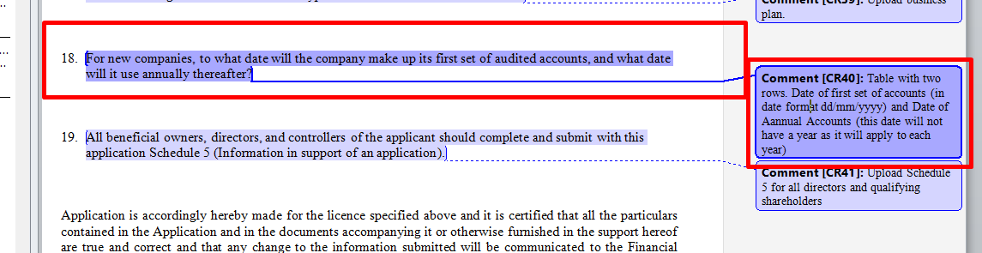

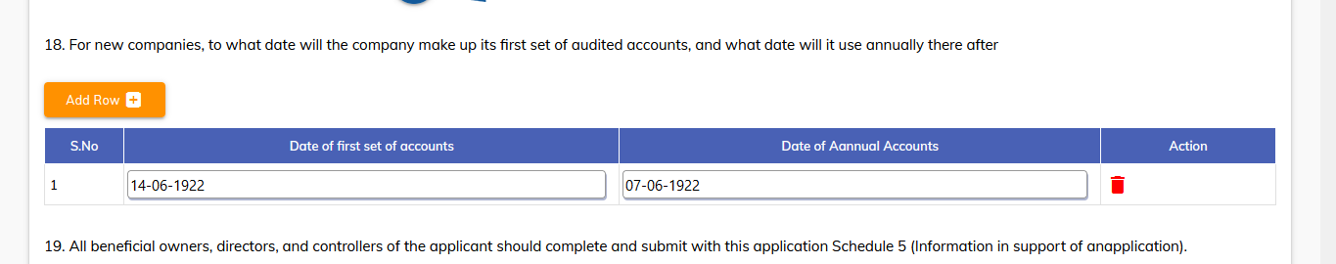

**MIPL Query:** Need explain this point/concern to client (For 2nd column)

**Client comment over call (June 8, 2022):**

Keep it as it is (Just need to add validation message)