1. ERSP—point 6—need to increase length of address 1 field.

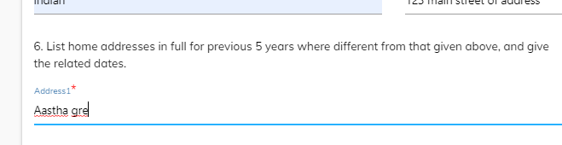

1. One time scrolling happens only for 20 years.

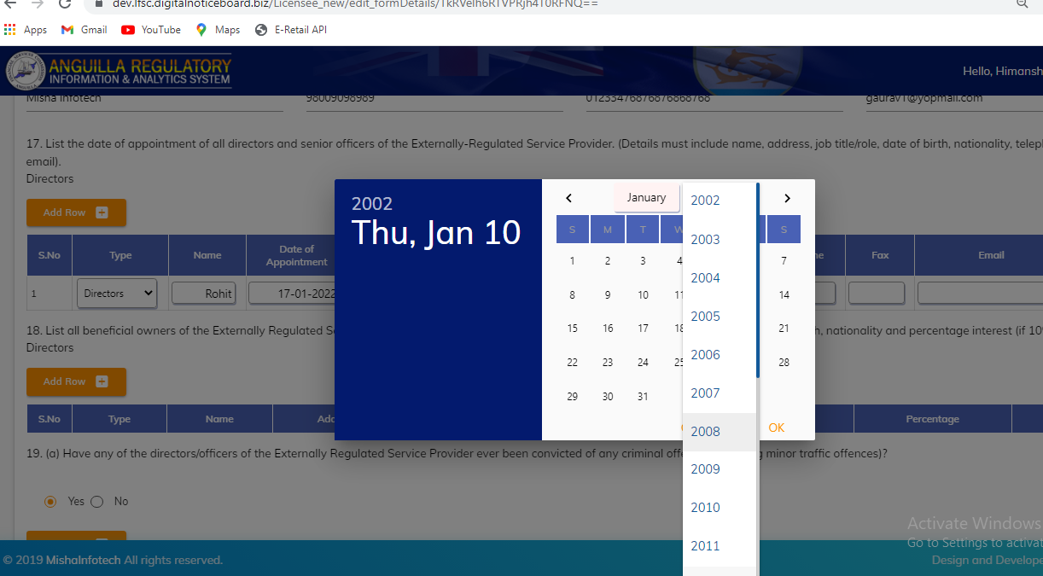

1. Schedule1—point 18—address should be accepted special character , alphanumeric character .

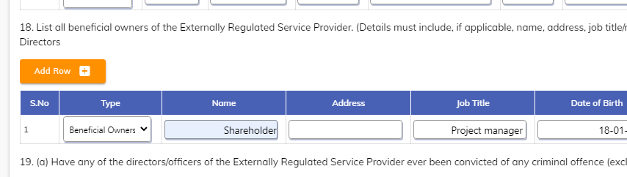

1. Admin panel—MLRO information is missing.

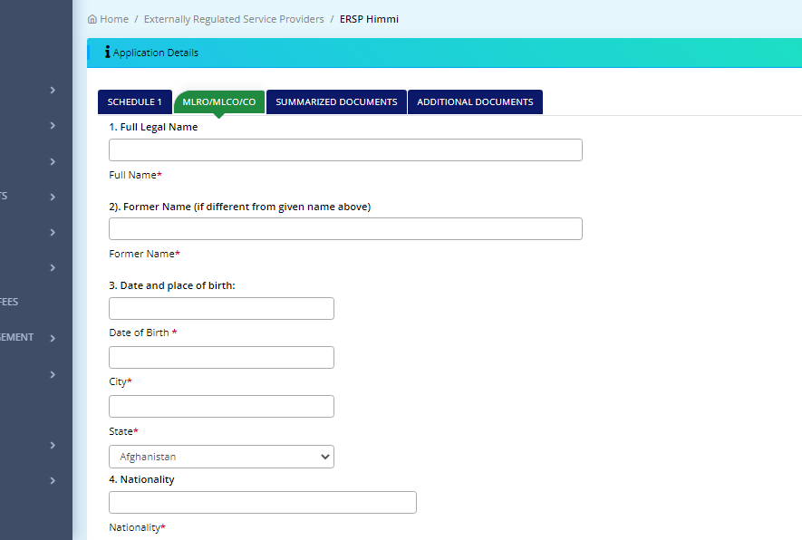

1. All the documents are missing at admin section.
2. MLRO form—point 17—1 row getting add automatically and sequencing issue.

